# English Group Discussion

Facial Recognition

Jucker Marco & Winkler Olivier, INF6J

10.06.2020, Version 1.0

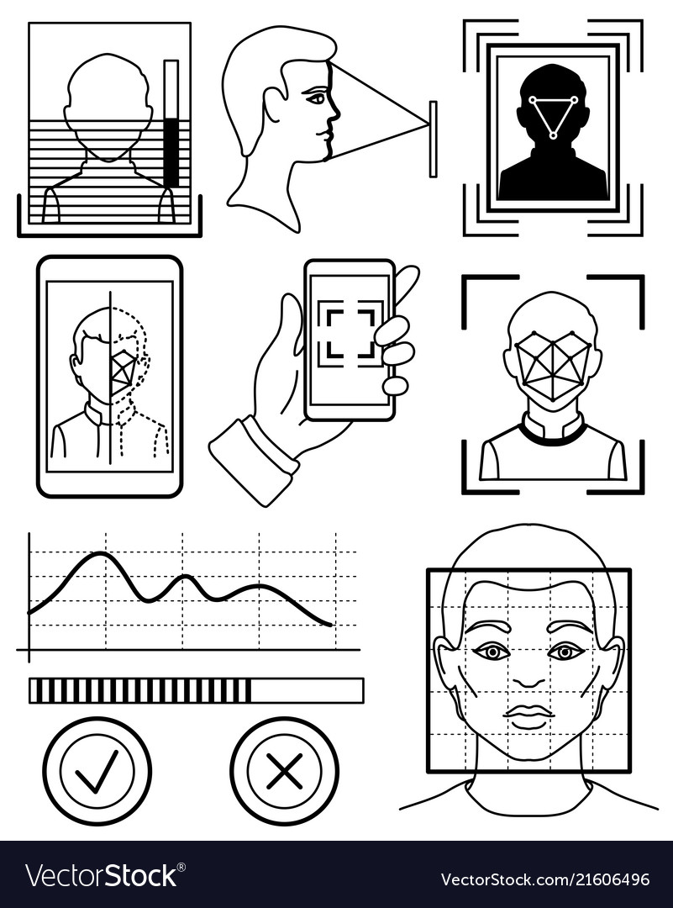

# Discussion

We are both very interested in this topic due to the opportunities this technology brings. Both think that the biggest disadvantage is the surveillance of people everywhere. Marco only had experience with it on his smartphone and probably in everyday life too, but he does not really pay attention to it. Olivier’s phone does not support facial recognition, so the only experience is by cameras. We both agree that the topic was well covered in the article with many illustrations and statistics about every continent. We learned which countries have which state of facial recognition technique with camera surveillance.

# Conclusion

Marco

I think it is a good idea to have control over people. Because it will be easier for the state to find criminals. But I think it should be handled very carefully. The population should only be monitored in densely populated areas (train station, popular areas, parks, …). In residential areas I personally find it unnecessary, so that the privacy of people is still guaranteed.

Olivier

This technology has many advantages. For example, with facial recognition wanted people can be found much easier than before. The only problem is the population. Not everyone is happy about that he or she is monitored by the government. I think it’s a good security factor in our country. I suggest that the technique should be installed in densely populated areas to guarantee security. But in residential areas or in sparsely populated areas it should be not installed.

# Assignment

Around the world, the facial recognition technology is currently in a high rising rate. This technology can be used from public CCTV cameras to biometric identification systems in airports. Since a few years, facial recognition can be used to unlock your smartphone and beside that its mostly the most good-natured form of facial recognition. Although in the state level usage, facial recognition is the key element of surveillance people in public. This technique already frequently occupies half of the globe’s population.

List of countries and state of technology they are using:

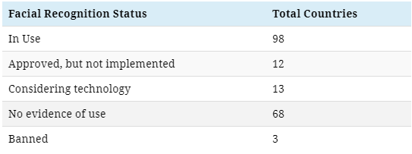

## North America, Central America & Caribbean

A study in 2016 revealed that already fifty percent of the American adults were captured in facial recognition networks. Currently the US has plans of using facial recognition technology on almost every air travel passenger to identify their visa & compliance status until 2023. Furthermore about 59% of Americans support the implementing path of facial recognition technology for use in law enforcement. But there are still cities such as San Francisco which have considered banning surveillance due to its potential abuse by the government.

## South America

In South America, the main goal of facial recognition is to demolish the crime rate, for example this technique worked in Brazil to jail Interpol’s second-most wanted criminal. Brazil is planning to create a biometric database of its citizens which are already reaching over 209 million. Due to the current political order, not everyone is happy about and considers it could be a mean to prevent dissent against politics.

## Europe

In Europe, there are two Belgium and Luxembourg of only three governments globally that oppose the use of facial recognition. About 80% of all Europeans have concerns about sharing data with authorities. Nevertheless, the technology is still in use across 26 countries. For instance, in Moscow alone are about 100’000 facial recognition enabled cameras in operation.

## Middle East and Central Asia

In this region facial recognition is mostly used only for military purposes only. E.G. Turkey recently bought 30 kamikaze drones with AI and facial recognition for border security, Israel spies on Palestinian citizens across 27 checkpoints and the UAE is using smart glasses to scan crowds with embedded lens displays and Kazakhstan is planning to replace public transportation passes by facial recognition technology.

## East Asia and Oceania

Due to the COVID-19 pandemic, facial recognition technology is in use to monitor temperatures as well as capturing people without masks. China is often criticised of mass surveillance. However, China has the highest ratio of CCTV cameras in the world, one for every 12 people. Estimates by 2023 result that China will be the single most valuable state in the global facial recognition market by implementing and exporting.

## Africa

Africa is the least concentrated continent in the world with facial recognition technology in use. But this is changing rapidly. Several African countries such as Kenya and Uganda were co-financed from Chinese companies – Huawei in particular to extend infrastructure for facial recognition. People are aware of this partnership, because as a Chinese company the data could easily exceed the country’s borders. Huawei claims that the partnership dropped the regional crime rate.